**Software insallation and steps to run automated testcases in STS.**

1. STS - 3.6.2 release (Latest Release) - https://spring.io/tools/sts/all
2. Java – JDK Installation 1.7 Version - http://www.oracle.com/technetwork/java/javase/downloads/jdk7-downloads-1880260.html
3. Maven repository - [http://maven.apache.org/download.cgi?Preferred=ftp://mirror.reverse.net/pub/apache/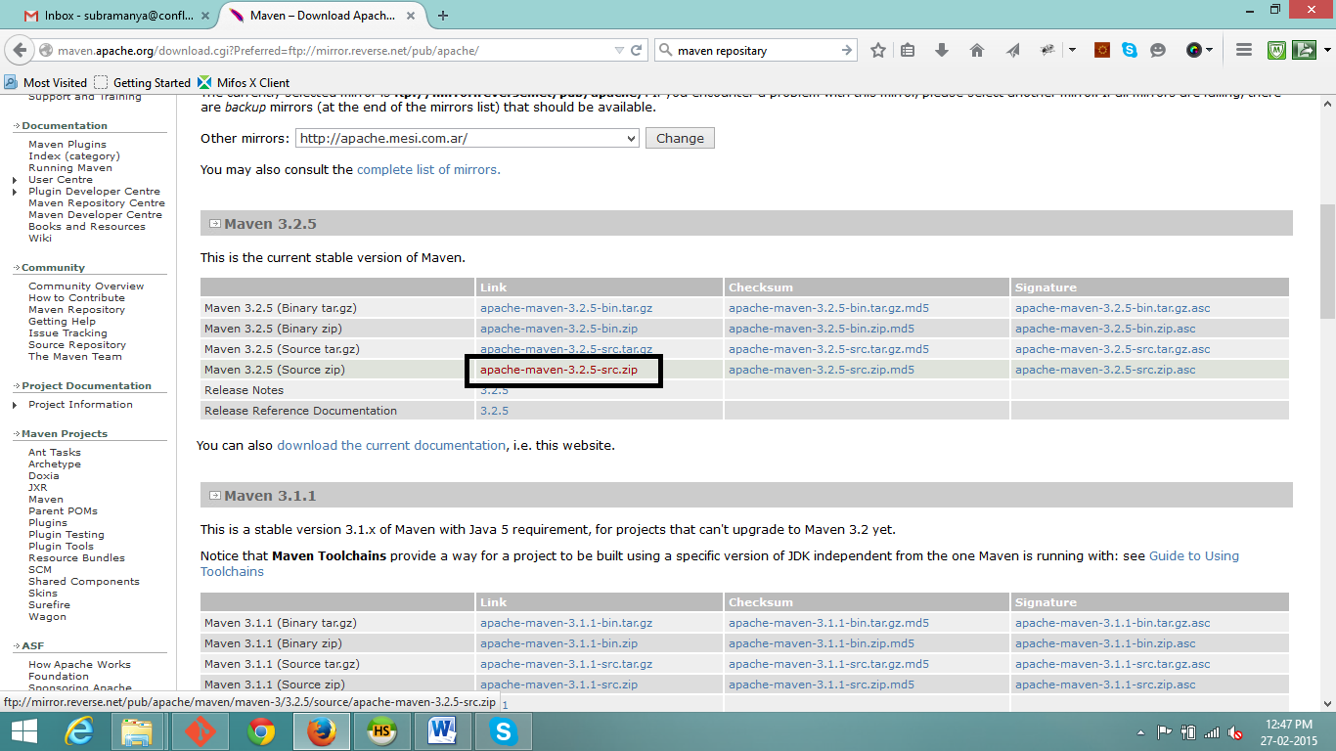](http://maven.apache.org/download.cgi?Preferred=ftp://mirror.reverse.net/pub/apache/)
4. Chrome driver.exe (in C drive of your local machine create one folder called ChromeDriver)

http://chromedriver.storage.googleapis.com/index.html?path=2.14/

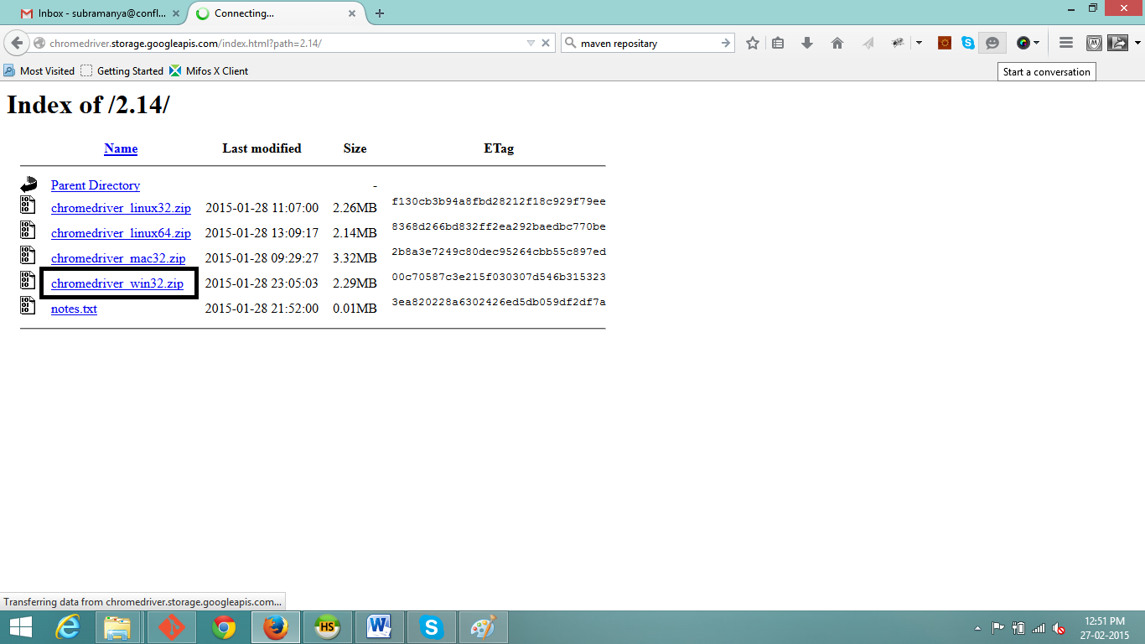

5.Create a folder and save the Zip folder (Mifos test automation )in to that and extract there.

6. Open Sts and create new workspace – Eg. C:\Mifos Automation.

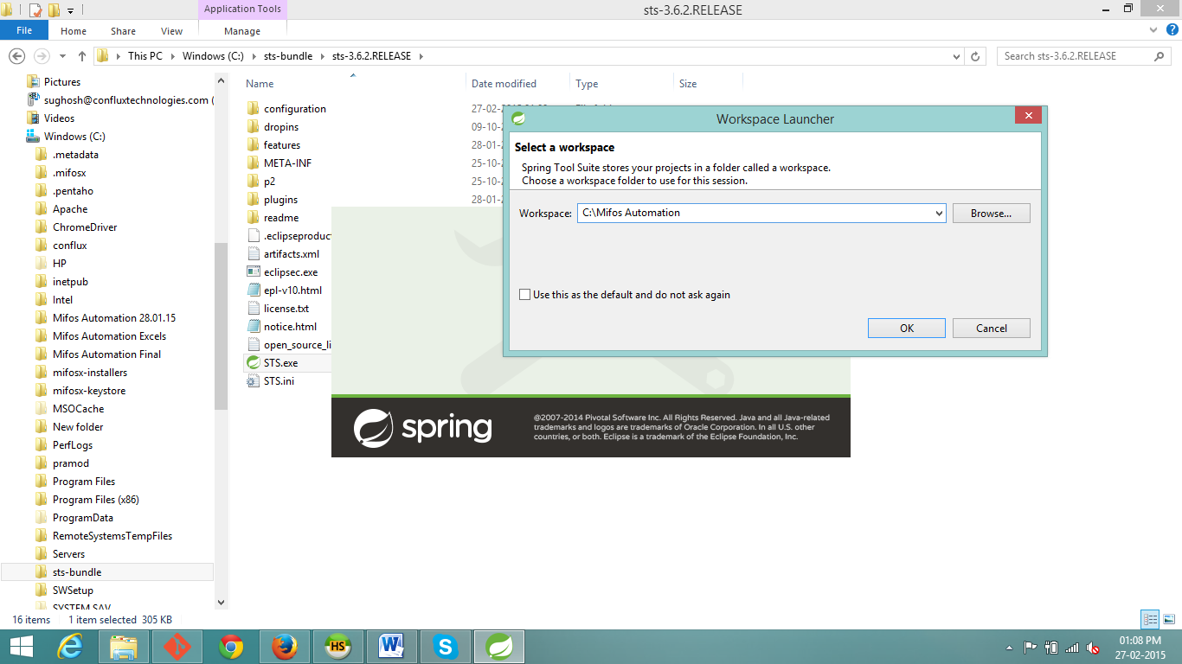

7.After Sts got opened click on File -> Import -> General -> Existing project into workspace and import 1) browsermob-proxy 2) Mifos testing framework 3) Mifos test Automation

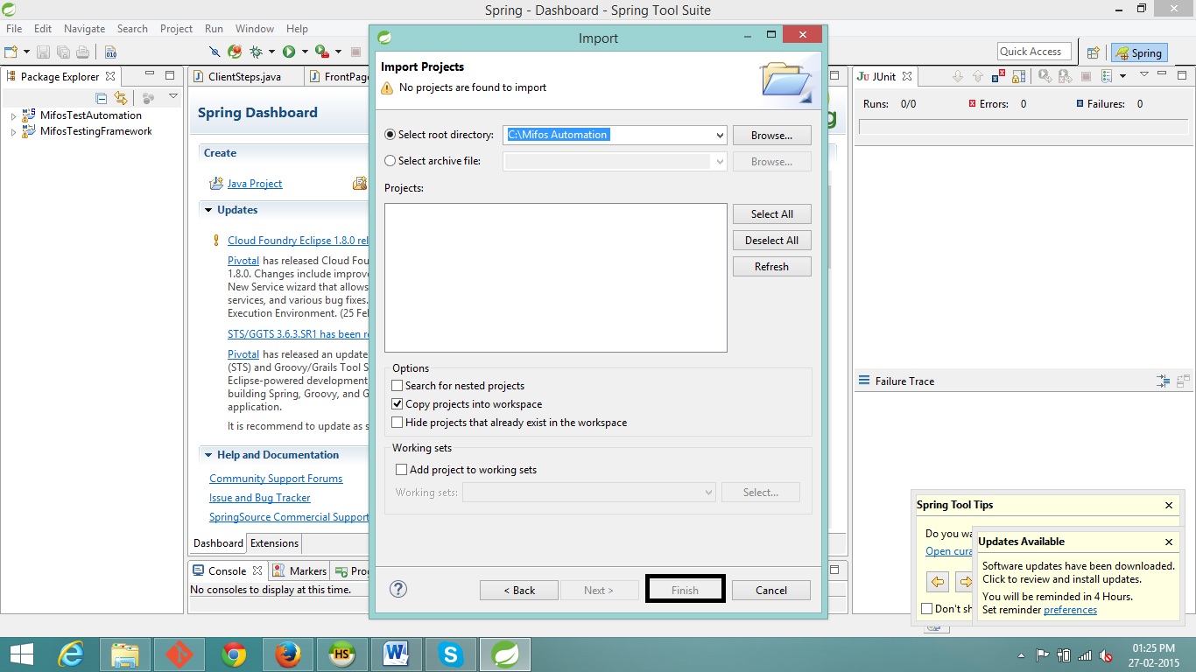

click on Next -> In Import projects page click on Browse and select the file location and in options as copy projects into work space -> Click on Finish.

8. In Spring tool page in top menu bar click on Project -> Click on Clean.

9. In Spring tool page in top menu bar click on File -> Click on Refresh.

10. Right click on browsermob-proxy -> Click on Run as -> Maven install

11. Right click on Mifos testing framework -> Click on Run as -> Maven install

12. Right click on Mifos test Automation -> Click on Run as -> Maven install

For all the above 3 Maven install the success message as Build success will get displayed in console of STS page.

13.Click on Mifos Test Automation ->src/test/resources ->double click on mifos.properties in which make sure you have site.base-url as [https://demo.openmf.org/#](https://demo.openmf.org/)

14.Click on Mifos Test Automation ->src/test/java ->com.mifos.test ->right click on Tests.java and run as Junit test.